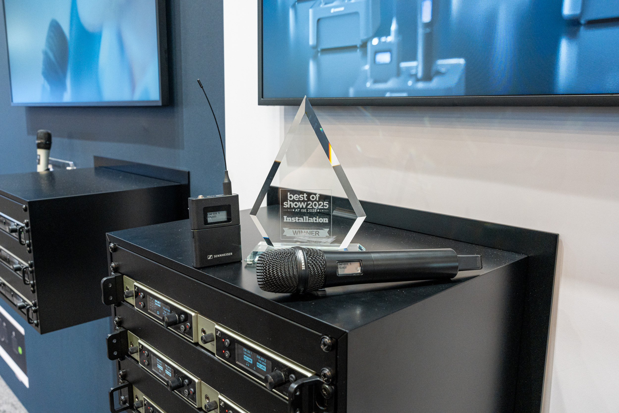

Sennheiser wins two Best of Show Awards at ISE 2025
Spectera, the world’s first wideband, bidirectional, digital wireless ecosystem, and Sennheiser EW-DX EM 4 DANTE receiver awarded by TVB Europe and Installation

Wedemark, February 2025 – Sennheiser is pleased to announce that two of its products shown at ISE – the four-channel EW-DX EM 4 Dante microphone receiver and Spectera, the company’s Wireless Multichannel Audio Systems (WMAS) solution – have won in this year’s Best of Show Awards. The prizes were presented by Installation and TVBEurope magazines.

The awards celebrate the finest innovations at ISE 2025, with hundreds of products and solutions evaluated by a panel of industry experts and editors. Factors considered include feature diversity, ease of use, and overall uniqueness and innovation within the market.

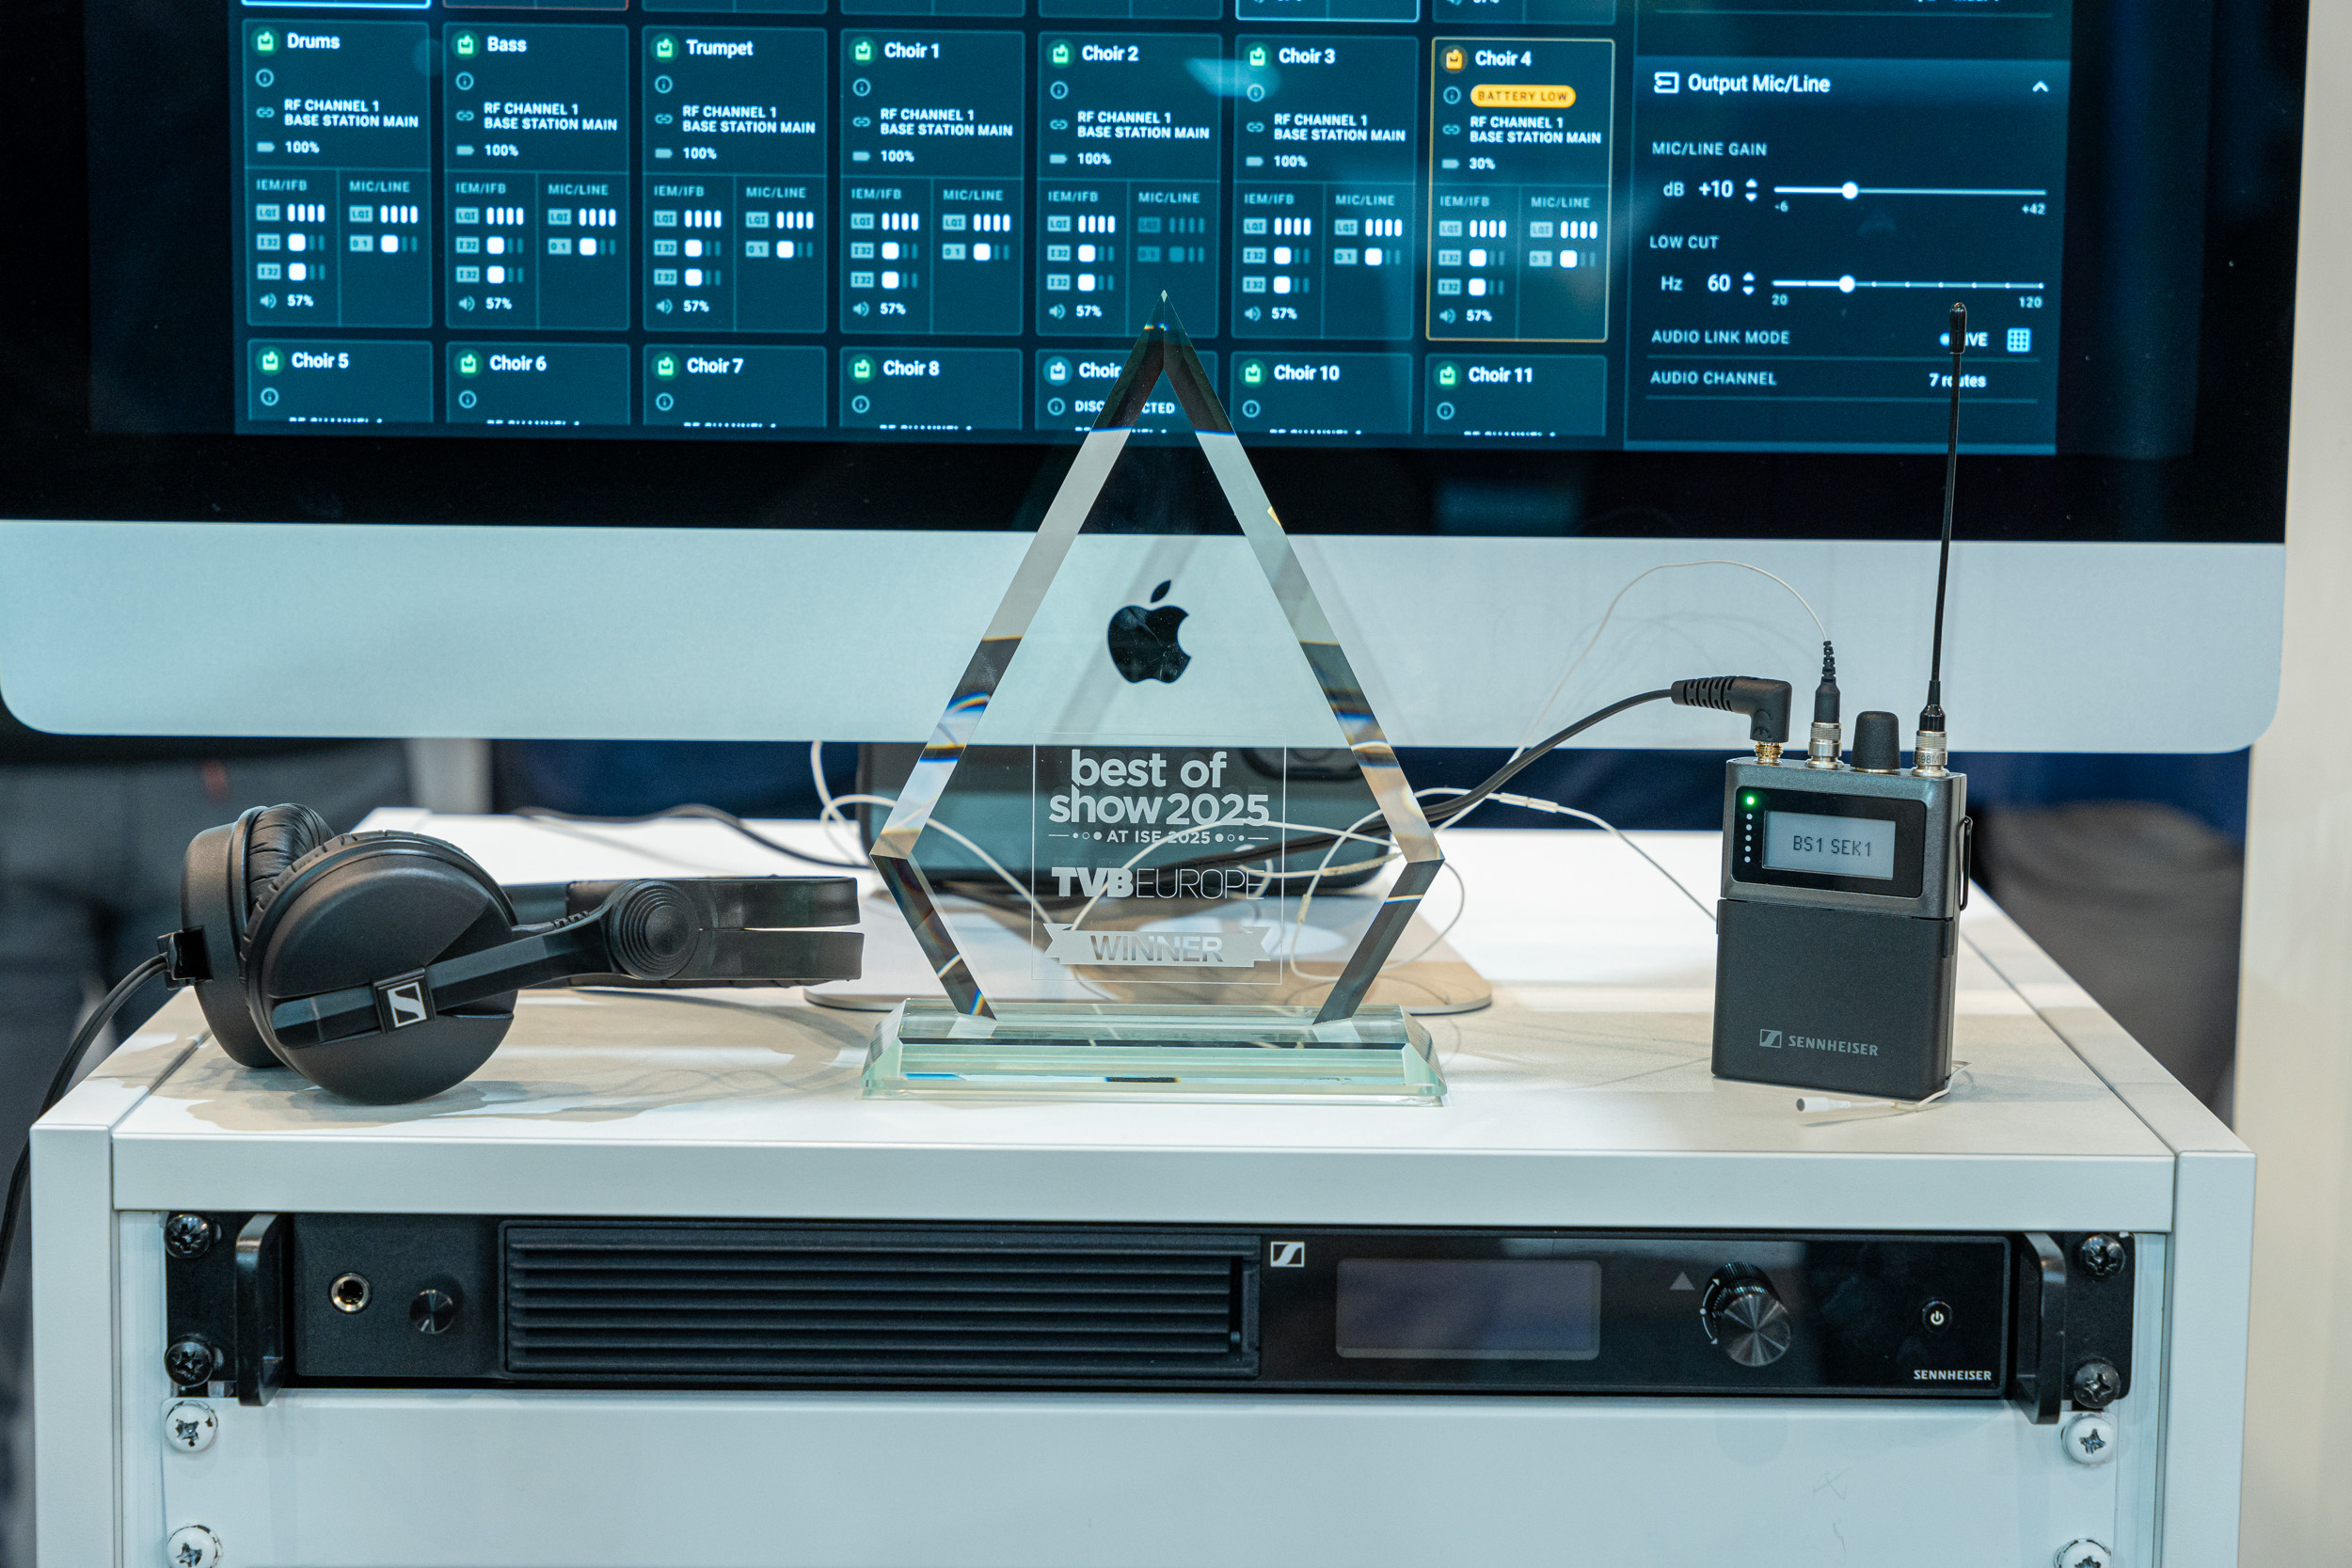 | While Installation honoured the EW-DX four-channel receiver, TVB Europe awarded Spectera with a Best of Show award

The awards’ editorial team have said that “We all experienced how busy ISE was this year; to stand out and be recognized as an official Best of Show winner is truly impressive and a testament to all of the hard work companies put into their products and solutions. Every winner should be really proud of their accomplishments – well-deserved congratulations from the entire awards team.”

 | 

The EW-DX EM 4 Dante receiver completes Sennheiser’s Evolution Wireless Digital EW-DX microphone offering. The network-ready, 4-channel receiver (19”, 1U) is an ideal choice for anybody specifying or setting up multichannel systems in live audio, touring, broadcasting, theatre, and system integration applications. The receiver seamlessly integrates into existing workflows and infrastructures, offering versatile connectivity via Dante (including AES 67 support) for audio over IP, as well as balanced XLR-3 audio outputs and unbalanced ¼” jacks.

Using ground-breaking WMAS wideband technology, the bidirectional Spectera ecosystem greatly reduces wireless complexity and footprint with up to 32 inputs and 32 outputs handled by the same 19”, 1 U rack-mount Base Station. At the same time, Spectera considerably increases capability, enabling time-saving workflows and offering full remote control and monitoring, including permanent spectrum sensing. Spectera features bidirectional bodypacks that manage both digital IEM/IFB and mic/line signals at the same time. The solution is remarkably resistant to RF fading and allows for flexible use of the wideband RF channel.

“We’re thrilled to have won these awards,” concludes Ron Holtdijk, Executive Vice-President Business Communication at Sennheiser. “It was incredible to showcase both the EW-DX EM 4 Dante and Spectera at ISE 2025, allowing visitors to experience them firsthand. Having the industry recognise both innovations is a huge honour and inspires us to keep pushing the limits of audio technology. We’re excited for what’s next for these solutions and look forward to continuing to shape the future of wireless audio.”

(Ends)

About the Sennheiser brand
We live and breathe audio. We are driven by the passion to create audio solutions that make a difference. Building the future of audio and bringing remarkable sound experiences to our customers – this is what the Sennheiser brand has represented for more than 75 years. While professional audio solutions such as microphones, meeting solutions, streaming technologies and monitoring systems are part of the business of Sennheiser electronic SE & Co. KG, the business with consumer devices such as headphones, soundbars and speech-enhanced hearables is operated by Sonova Holding AG under the license of Sennheiser.

www.sennheiser.com
www.sennheiser-hearing.com

Global Press Contacts
Jeff Horan Stephanie Schmidt
jeff.horan@sennheiser.com stephanie.schmidt@sennheiser.com
+1 (860) 598 7539 +49 (5130) 600 – 1275

